GRAB TECH INSIDER:
Food Delivery with a Southeast Asian Flavour
Summary sheet
Presentation by: Xiaole Kuang, Head of Engineering, Deliveries, Grab.

Enhancing Eaters’ Experiences on GrabFood
We build and iterate existing tech with the aim of delivering a delightful experience for our users when they browse, order and wait for their food to arrive. When building food delivery tech, we think about how we can:
- Enable localisation at scale
- Delight eaters and drive sustainable demand for our merchant-partners .
- Protect eater experiences in crunch time

Browse: Relevant options personalised for you

Relevance: Localising GrabFood homepages | - Country teams have the ability to customise various sections on the GrabFood home page to highlight what’s more relevant to their customers based on consumption patterns derived from their ordering habits.  - This includes ability to localise content on display banners, categories and carousel.  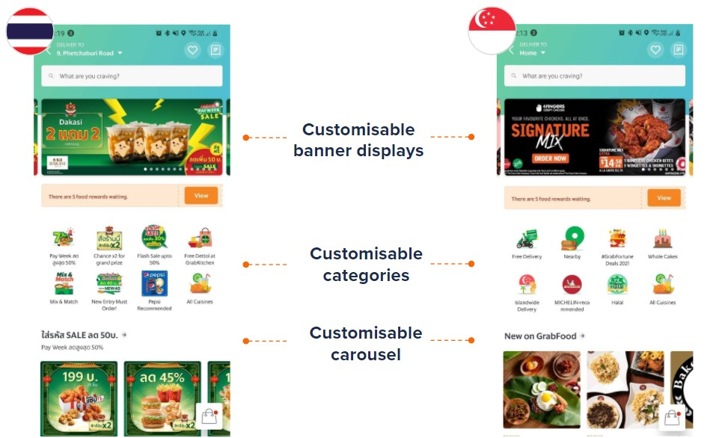
Relevance: Recommending alternative options | - If a dish or restaurant a user searched for is unavailable or has less than 4 options, the app finds similar merchants based on keyword similarities on the menu, powered by machine learning capabilities.  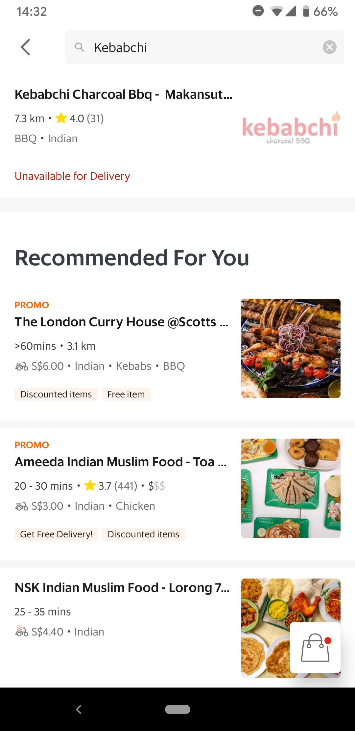
Personalisation:  Ranking Logic | - The GrabFood app is able to provide personalised recommendations based on what consumers enjoy.  - Recommendations are arranged based on our ranking logic which considers numerous factors. These include::  - General factors such as merchant popularity, Estimated Time of Arrival (ETA), driver availability, etc.  - Individual factors such as past browsing and ordering history (e.g. cuisine / budget / food preferences)  - Merchants that most closely match your profile are listed first.
Personalisation in Real-time | - The ‘Recommended for You’ section in the GrabFood homepage is also personalised for users in real-time based on their search patterns.  - For example, users who are searching for a particular fast-food restaurant will see the section being updated to show other similar fast food options almost immediately!

Order: Multiple ordering options with tools to support merchants’ ops

For our customers, we currently offer 5 types of ordering functions within the app:

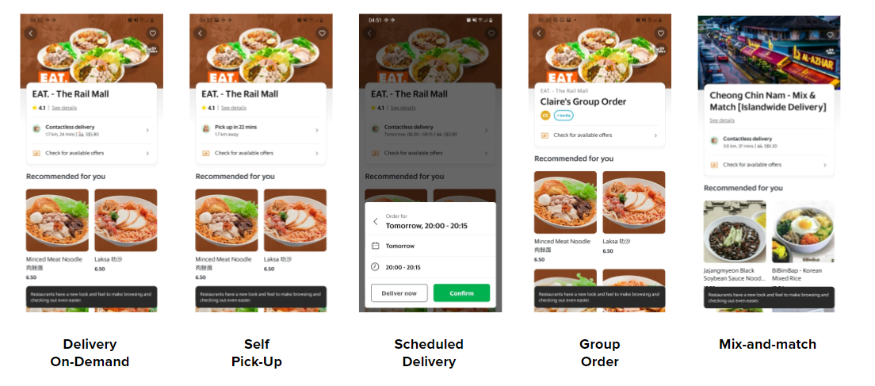

For our merchant partners, we have worked on several back-end technology products to make fulfilment more efficient:

Order Platform | - To facilitate smooth order handling, the team has developed an order platform that combines over 10 connected systems.  - What the platform does:  - Provides a 360 view of all incoming orders regardless of the order type (delivery on-demand, self pick-up, scheduled delivery, group ordering, mix-and match)  - Enables merchants to keep their restaurant information updated - e.g. whether an item is out of stock, or any changes to operating hours  - Offers analytics tools in the GrabMerchant app so merchants can understand customers’ purchasing behaviours and create relevant campaigns for them  - Offers Open Platform tools to improve operational efficiency and make the integration process as smooth as possible (see example below)
Point of Sale (POS) Integration | 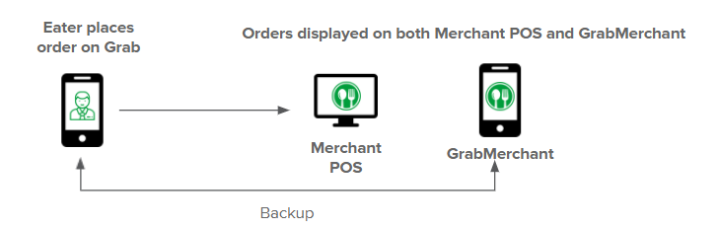  - An example of an Open Platform tool we have developed for merchant-partners is the Point of Sale integration, which lets them link their POS system used in their own restaurants with GrabMerchant.  - Before POS integration: Merchant’s staff have to manually transfer GrabFood orders from the GrabMerchant app into their restaurant POS.  - With the integration, GrabFood orders flow straight into the restaurant POS, and right into the kitchen. Whenever merchants update their menus in the restaurant POS system, it will be reflected in the GrabFood app immediately.  - This means that merchants only need to manage one system, and helps them save time and improve accuracy.
Self-Serve Integration | - To encourage and enable more merchant-partners to integrate their POS systems with GrabMerchant, the team has also developed a Self-Serve System which includes step by step guides, testing and debugging tools to help merchants set up POS integration on their own.  - Our tech team remains ready to support merchant-partners should they face any technical issues.

Wait: On-time preparation and Driver Availability

On-Time Preparation | - Accurate food preparation time estimations are essential in our overall ETA calculation.  - On average, drivers spend 6-11 minutes waiting in restaurants for merchants to finish preparing their orders.  - Because preparation habits may differ across markets, Grab is testing out different features to encourage merchants to prepare food more promptly and to minimise waiting time for drivers at restaurants.
Optimising fleet - Batching | - With order batching, our system can assign two or more consumer orders with nearby drop-off or pick-up points for a driver to complete in a single trip.  - Order batching was developed to help us optimise our fleet, especially during peak hours and supply crunch time, such as when there’s a heavy downpour at dinner time.
Optimising fleet – Radius Reduction | - In supply crunch times when there’s too many orders and too few delivery riders in an area, eaters may have to wait very long for a delivery-rider. Chances of merchants cancelling an order is also higher as they may be operating at maximum capacities.  - When driver allocation rate and order completion rate decline severely, our system kicks in to start gradually reducing the delivery radius.  - This helps to concentrate delivery-riders within a smaller area, to help improve order completion rates  - This is applied until order completion rate stabilises and more delivery-partners are available in the area.
###

